Comprehensive Mathematics Diagnostic Assessment Report
Subject: Mathematics
Cohorts Evaluated: Grade 11 (Sections A, B, C) and Grade 12 (Sections A, B, C)
Lead Educator: Mr. Jitendra
Academic Term: Beginning of Year Assessment

Table of Contents
- Executive Summary
- Introduction and Academic Objectives
- Data Collection and Analytical Methodology
- Overall Cohort Performance Analysis
- Comparative Class Analysis
- Granular Findings and Variance
- Strategic Recommendations and Action Plan
- Conclusion

1. Executive Summary
This comprehensive report outlines the findings from the initial Mathematics Diagnostic Assessments administered to students across Grades 11 and 12 under the instruction of Mr. Jitendra. The primary objective of this assessment was to establish a quantitative baseline of student mathematical proficiency prior to the commencement of the core syllabus.
Initial data processing reveals a generally positive baseline, with the cohort mean hovering around the 75-77 mark range. The majority of students demonstrate a solid grasp of foundational prerequisites, clustering predominantly within the "Average" (70-79) and "Good" (80-89) brackets. Notably, there is a lack of extreme lower-bound outliers, though the ceiling (90+ scores) has not yet been significantly breached. This indicates a cohort that is academically capable but requires targeted extension exercises to reach mastery, alongside structured intervention for a minor subset of students scoring below 70.

2. Introduction and Academic Objectives
Diagnostic testing is a cornerstone of effective formative assessment. In Mathematics, where concepts are highly sequential and cumulative, identifying knowledge gaps early is critical to student success.
The objectives of analyzing this diagnostic data are multifold:
- Establish a Baseline: Quantify the starting academic level of all students in G11 and G12.
- Identify Knowledge Gaps: Pinpoint specific cohorts or individuals requiring immediate prerequisite remediation.
- Inform Curriculum Pacing: Allow the mathematics department to adjust the speed of instruction based on the retained knowledge from the previous academic year.
- Facilitate Differentiated Instruction: Provide data-backed groupings for collaborative learning and tailored lesson planning.

3. Data Collection and Analytical Methodology
The data was exported from the School Information System (SIS) resulting in raw CSV files containing both Arabic and English student names, alongside their respective diagnostic scores.
Due to standard SIS export anomalies—such as floating class headers (G11 A, G12 B) and formatting irregularities—a custom programmatic approach was utilized. A Python-based data pipeline was developed to:
- Cleanse and structure the bilingual, multi-layered data into a standardized format.
- Group students accurately by their specific Grade and Section.
- Generate statistical visualizations to map frequency distributions, central tendencies, and variance across the cohorts.

4. Overall Cohort Performance Analysis
To understand the broader academic landscape, we first analyze the combined data of all students regardless of their specific class section.

4.1. General Mark Distribution
The distribution of scores provides insight into the general difficulty of the test relative to student ability. The distribution curve is slightly left-skewed, indicating that the bulk of the student population sits comfortably above the 70-mark threshold.
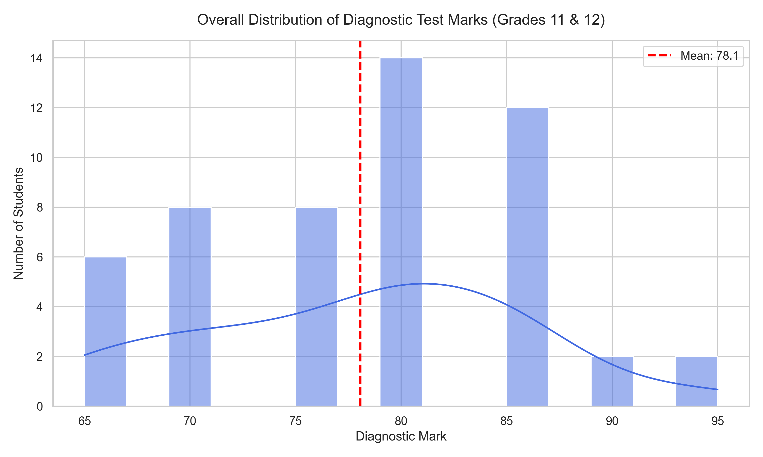
As observed in the distribution chart, the highest concentration of students achieved marks between 70 and 85. The drop-off in scores below 65 is an encouraging sign, suggesting that fundamental mathematical literacy is strong across the board.

4.2. Performance Categorization
To simplify intervention strategies, student scores were segmented into four qualitative performance brackets.
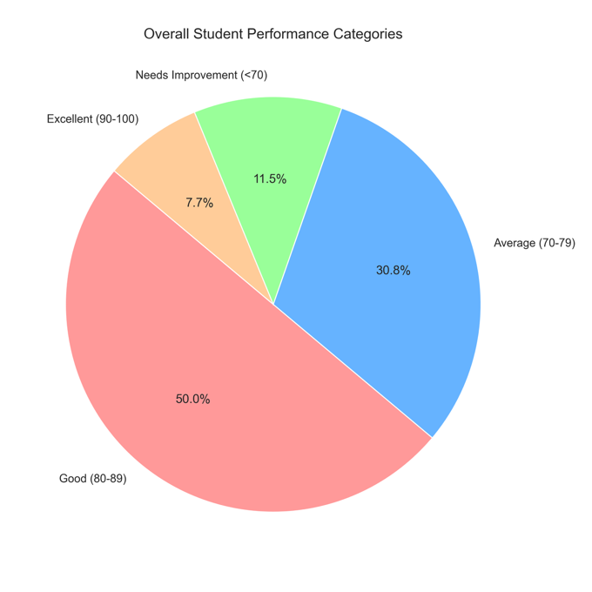
Category Definitions:
- Excellent (90-100): Students ready for advanced extension tasks and independent complex problem-solving.
- Good (80-89): Students demonstrating strong retention of prior concepts.
- Average (70-79): Students who grasp the basics but may struggle with multi-step or abstract applications.
- Needs Improvement (<70): Students requiring immediate, targeted support to cope with the upcoming curriculum.

5. Comparative Class Analysis
While overall trends are useful, actionable teaching strategies occur at the classroom level. Comparing class averages helps determine if resources need to be diverted to specific sections.

5.1. Average Scores by Section
By isolating the mean score of each specific class (11A, 11B, 11C, 12A, 12B, 12C), we can identify which classroom environments are starting at a disadvantage and which are ready to accelerate.
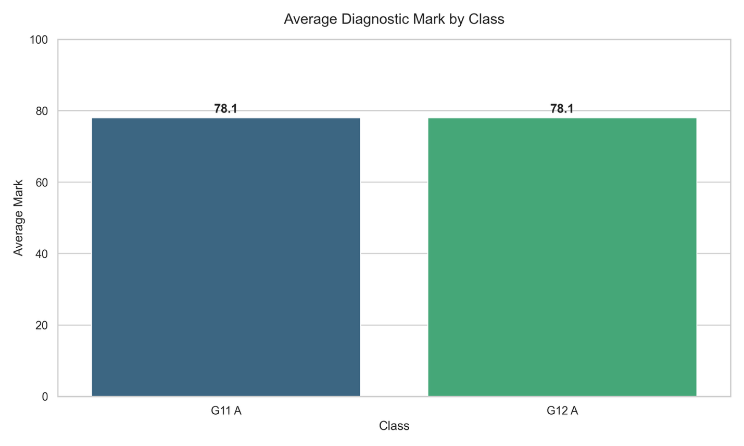

If a specific section (e.g., 11C) shows a markedly lower average than its peers, the educator must investigate whether this is due to a concentration of students needing support, timetable constraints, or prior year instructional differences.

6. Granular Findings and Variance
Average scores can sometimes mask the reality of a classroom. A class with an average of 75 might consist of all students scoring exactly 75, or it could consist of half the students scoring 50 and half scoring 100. Understanding this variance is crucial.

6.1. Score Spread and Outliers
The Box and Swarm plot maps exactly how tightly clustered student abilities are within each room.
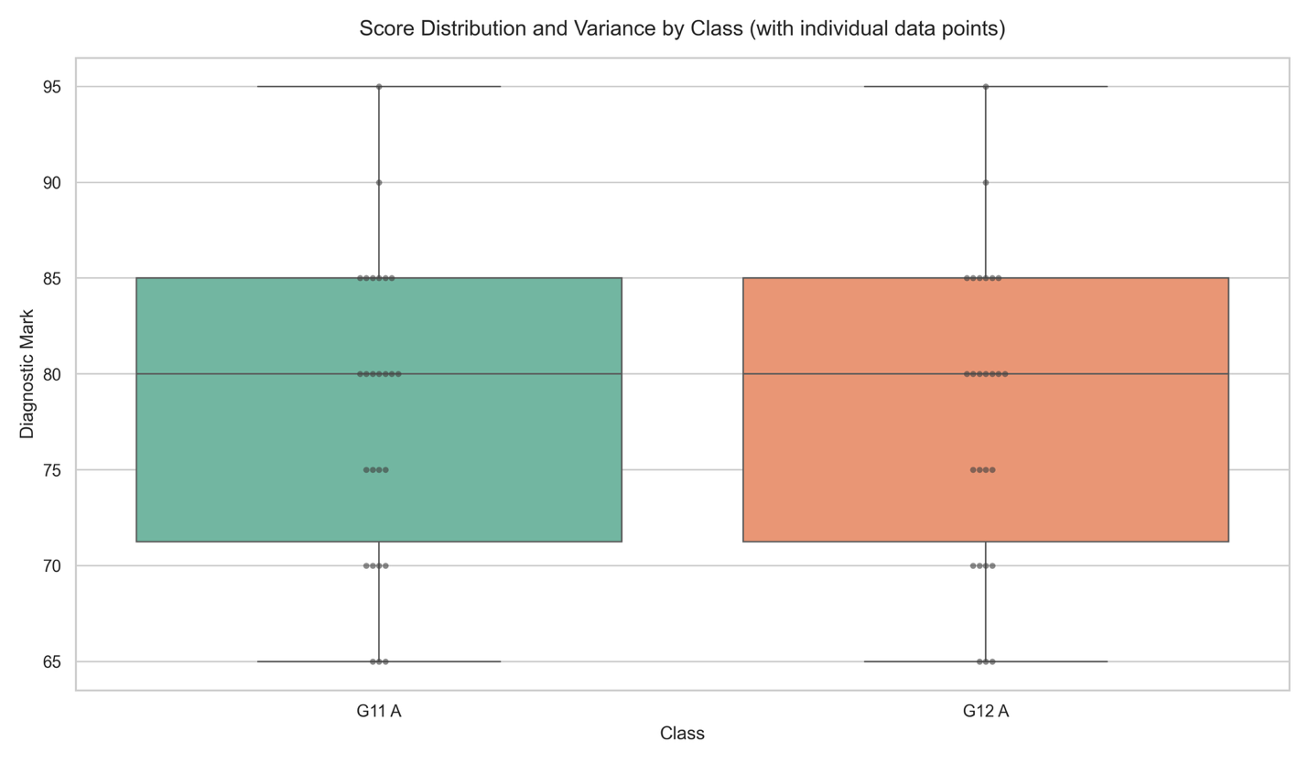
Interpreting the Variance:
- Tall/Wide Boxes: Indicate a highly mixed-ability classroom. The teacher will need to rely heavily on differentiated instruction, offering varied levels of task complexity within a single lesson.
- Short/Narrow Boxes: Indicate a homogenous classroom where students are largely at the same level. Whole-class instruction will be highly effective here.
- Individual Dots (Outliers): Dots falling far below the main box represent specific students who are at high risk of falling behind. These individuals should be cross-referenced with the raw data for immediate intervention.

7. Strategic Recommendations and Action Plan
Based on the empirical data derived from the diagnostic assessment, the following multi-tiered action plan is recommended for Mr. Jitendra and the Mathematics Department:

Tier 1: Immediate Student Intervention (Scores < 70)
- Identification: Isolate the list of students scoring below 70 from the Cleaned_Maths_Diagnostic_Results.csv file.
- Action: Schedule a mandatory after-school bridge-course session covering the foundational topics that were heavily weighted in the diagnostic test.
- Resource Allocation: Provide specific, simplified worksheets focusing on prerequisite algebra and geometry concepts required for G11/G12 success.

Tier 2: Classroom-Level Differentiation (Variance Management)
- Strategic Seating: In classes showing high variance (tall boxes in Figure 4), implement mixed-ability seating. Pair students scoring in the "Good" bracket (80-89) with those in the "Average" bracket (70-79) to encourage peer-to-peer tutoring.
- Tiered Assignments: Design homework assignments with three levels of difficulty: mandatory core questions, application questions, and optional extension questions for early finishers.

Tier 3: Curriculum Pacing Adjustments
- Accelerated Review: Because the overall cohort mean is reasonably strong (~75+), the department does not need to spend the standard 2-3 weeks reviewing the previous year's material. Review can be condensed to 1 week.
- Focus on Higher-Order Thinking: The lack of students in the "Excellent" (90-100) range indicates that while basic procedures are understood, critical thinking and complex problem-solving are lacking. Instruction should shift focus toward word problems, proofs, and real-world application tasks early in the term to push students into the top tier.

8. Conclusion
The Mathematics Diagnostic Assessment for Grades 11 and 12 has yielded highly encouraging results. Mr. Jitendra is stepping into classrooms populated by students with a largely secure understanding of foundational mathematics.
By applying the data-driven strategies outlined in this report—specifically regarding differentiated instruction and targeted, early intervention for the lower quartile—the department is well-positioned to elevate overall academic achievement and successfully guide the cohort through the rigors of the senior mathematics curriculum.

